**Name:**

**Chapter 4 Week 6 Programming Challenges (40 points)**

In finishing our Chapter 4 reading, we learned about the following topics:

* Relational Operators
* The *if* statement
* Expanding the *if* statement
* The *if/else* statement
* Nested *if*
* The *if/else* statement
* Flags
* Logical Operators
* Menus
* Comparing characters and strings
* The Conditional Operator
* The *switch* statement
* Blocks and scope

These techniques allow us to ask for input from the user, make calculations using various data types, and display that output in a user-friendly format. This lab asks you to write two programs which implement some of these topics. When developing your programs, please remember to add your header information. Use comments to self-document your code and be mindful of the spelling and formatting of your data, both *input* and *output*. Try to use different decision structures throughout your code. Please look at the examples I provide. You can opt for your own format but I expect to see the same information results.

**Program 1**

**Days in a Month**

Write a program that asks the user to enter the month (letting the user enter an integer in the range of 1 through 12) and the year. The program should then display the number of days in that month. Use a ***switch*** statement for this program. Use the following criteria to identify leap years:

* Determine whether the year is divisible by 100. If it is, then it is a leap year if and only if it is divisible by 400. For example, 2000 is a leap year but 2100 is not.
* If the year is not divisible by 100, then it is a leap year if and only if it is divisible by 4. For example, 2008 is a leap year but 2009 is not.

For example:

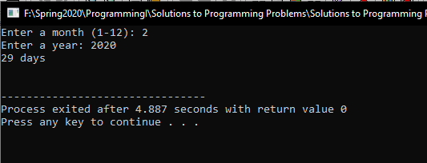

**Program 2**

**Book Club Points**

Local Booksellers has a book club that awards points to its customers based on the number of books purchased each month. The points are awarded as follows:

* If a customer purchases 0 books, he or she earns 0 points.
* If a customer purchases 1 book, he or she earns 10 points.
* If a customer purchases 2 books, he or she earns 15 points.
* If a customer purchases 3 or 4 books, he or she earns 20 points.
* If a customer purchases 5 to 10 books, he or she earns 25 points.
* If the customer purchases over 10 books, he or she earns 50 points.

Write a program that asks the user to enter the number of books he or she has purchased this month then displays the number of points awarded. Check for negative values or invalid values and display appropriate error messages.

**For example:**

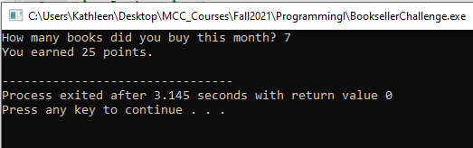

You can upload your results when you are done with the **Chapter 4 Week 6 Programming Challenges** assignment under our **Assignments** tab in Blackboard.